Secure AWS Infrastructure Deployment Using Ansible

Description
Scenario: Your organization is deploying a secure cloud environment on Amazon Web Services (AWS) to host both public-facing administrative workloads and internal in-house services. The infrastructure must be: - Secure by design - Segmented according to least privilege - Fully automated using Ansible - Aligned with AWS Well-Architected Framework principles - Mapped to relevant NIST security controls Objective: Using Ansible playbooks, provision a production-grade AWS infrastructure that enforces network isolation, controlled access, and governance-aligned security controls.

Instructions
Infrastructure Requirements 1. Network Architecture a. Create one VPC with CIDR: 10.0.0.0/16 b. Create two subnets within the VPC: Public Subnet: 10.0.1.0/24 Private Subnet: 10.0.2.0/24 c. Attach an Internet Gateway to the VPC d. Configure route tables: Public subnet routes internet traffic (0.0.0.0/0) via Internet Gateway Private subnet has no direct internet route Design intent: Enforce network segmentation and attack surface reduction. Security Requirements: a. Use separate security groups: - Public EC2 SG: Allow SSH from trusted IP range only - Private EC2 SG: Allow SSH only from the public EC2 security group b. No inbound internet access to private EC2 Ansible Implementation Requirements: a. Use AWS-native Ansible modules (no CLI or shell execution) b. Use collections: amazon.aws community.aws c. Playbook must be idempotent d. Variables must be externalized (region, CIDRs, instance types) e. No hardcoded credentials f. Clear task naming and logical structure Expected Outcome: After successful execution: - A secure AWS VPC with public and private subnets exists - Public EC2 is reachable from approved networks - Private EC2 is accessible only via the public EC2 - Infrastructure aligns with AWS Well-Architected and NIST security principles - Environment is audit-ready and production-aligned

Structure -
Ansible/
├── vars.yml (External variables such as AWS region, VPC CIDR, subnet CIDRs, AMI ID, instance type, and trusted SSH IP)
├── playbook.yml (Main playbook that runs the network and instance configuration)
├── network.yml (Creates the VPC, public/private subnets, Internet Gateway, and route tables)
└── instances.yml (Creates the public/private security groups and EC2 instances)

Step 1: Create the External variables file (vars.yml)

Modify the trusted_admin_ip value to match the actual public IP address.
Run curl ifconfig.me to find local PC’s public IP
If the result looks like four numbers separated by dots (e.g., 198.51.100.45), add /32 to the end. The /32 tells AWS to look at this exact single computer.

Vars.yml - The vars.yml file is the settings sheet for my entire project.
Instead of writing specific details (like IP addresses, region names, or server sizes) directly inside the main code file (playbook.yml), I put them into this separate file.

---
# AWS configuration
aws_region: eu-west-2

# VPC configuration
vpc_name: secure-ansible-vpc
vpc_cidr: 10.0.0.0/16

# Subnets
public_subnet_name: public-subnet
public_subnet_cidr: 10.0.1.0/24

private_subnet_name: private-subnet
private_subnet_cidr: 10.0.2.0/24

# Availability Zone
availability_zone: eu-west-2a

# Internet Gateway
internet_gateway_name: secure-ansible-igw

# Route tables
public_route_table_name: public-route-table
private_route_table_name: private-route-table

# Security groups
public_security_group_name: public-ec2-sg
private_security_group_name: private-ec2-sg

# Trusted SSH source
# CHANGE THIS to my own trusted public IP/CIDR.
trusted_ssh_cidr: "82.1.213.244/32"

# EC2 configuration
public_instance_name: public-admin-server
private_instance_name: private-internal-server

public_instance_type: t3.micro
private_instance_type: t3.micro

# Amazon Linux 2023 AMI for eu-west-2.

ami_id: ami-06f9e3b45a89cf4aa

# SSH key pair already existing in AWS
key_name: Ansible
Playbook.yml
It tells Ansible where to run the instructions and in what order.
- hosts: localhost & connection: local: Tell Ansible to execute these commands right from my local pc rather than reaching out to an external server to run them.
- vars_files: [ vars.yml ]: Imports my settings sheet vars.yml so that all tasks can understand variables like {{ vpc_name }}.
- Amazon.aws.ec2_vpc_net: Provisions the virtual isolated data center inside AWS (the VPC). It saves the outcome into a temporary memory variable named vpc.
- amazon.aws.ec2_vpc_igw: A virtual "modem" (the Internet Gateway) and connects it directly to newly created VPC ID so public traffic can flow in and out.
- include_tasks:Instead of hundreds of lines of code into one massive file, it cleanly reads and runs sub-files (network.yml and launch_instances.yml) one after the other.
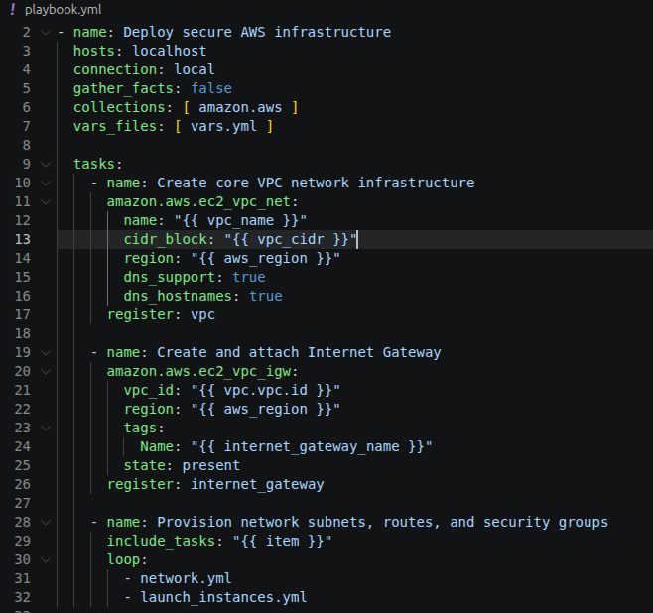

network.yml
This file is set up as an actual network.
- Subnet Creation: Builds the actual Public and Private subnets based on vars.yml.
- Route Tables:
  - Public Route Table: Maps a route for internet traffic (0.0.0.0/0) to head straight out through Internet Gateway.
  - Private Route Table: Lacks an internet route entirely, keeping any server placed here fully isolated from the web.
- Subnet Associations: Pins the Public Route Table directly to my Public Subnet, and the Private Route Table to my Private Subnet.

---
- name: Build subnets
amazon.aws.ec2_vpc_subnet:
vpc_id: "{{ vpc.vpc.id }}"
cidr: "{{ item.cidr }}"
az: "{{ availability_zone }}"
region: "{{ aws_region }}"
map_public: "{{ item.public }}"
tags:
Name: "{{ item.name }}"
Network: "{{ item.type }}"
loop:
- cidr: "{{ public_subnet_cidr }}"
public: true
name: "{{ public_subnet_name }}"
type: public
- cidr: "{{ private_subnet_cidr }}"
public: false
name: "{{ private_subnet_name }}"
type: private
register: subnets

- name: Build route tables
amazon.aws.ec2_vpc_route_table:
vpc_id: "{{ vpc.vpc.id }}"
region: "{{ aws_region }}"
tags:
Name: "{{ item.name }}"
subnets:
- "{{ subnets.results[item.idx].subnet.id }}"
routes: "{{ item.routes | default(omit) }}"
loop:
- name: "{{ public_route_table_name }}"
idx: 0
routes:
- dest: "0.0.0.0/0"
gateway_id: "{{ internet_gateway.gateway_id }}"
- name: "{{ private_route_table_name }}"
idx: 1

- name: Build public security group
amazon.aws.ec2_security_group:
name: "{{ public_security_group_name }}"
description: "SSH Admin"
vpc_id: "{{ vpc.vpc.id }}"
region: "{{ aws_region }}"
rules:
- proto: tcp
ports:
- 22
cidr_ip: "{{ trusted_ssh_cidr }}"
rule_desc: "SSH from trusted IP range"
rules_egress:
- proto: all
cidr_ip: "0.0.0.0/0"
register: public_sg

- name: Build private security group
amazon.aws.ec2_security_group:
name: "{{ private_security_group_name }}"
description: "SSH Private"
vpc_id: "{{ vpc.vpc.id }}"
region: "{{ aws_region }}"
rules:
- proto: tcp
ports:
- 22
group_id: "{{ public_sg.group_id }}"
rule_desc: "SSH only from public EC2 security group"
rules_egress:
- proto: all
cidr_ip: "0.0.0.0/0"
register: private_sg

launch_instances.yml
This file handles the deployment Security Groups and runs the actual virtual machines (EC2 instances).
- Public Security Group Rules: Configures an absolute lockdown on the public server. It permits inbound SSH (Port 22) traffic only if it originates from your specific trusted_ssh_cidr.
- Private Security Group Rules: Configures a strict Least Privilege lockdown. It blocks the entire general internet. It only permits SSH commands if they are coming directly from the Public server.
- EC2 Instance: Uses the amazon.aws.ec2_instance module to launch two live servers:
  - The Public Admin Server inside the Public Subnet.
  - The Private Internal Server inside the Private Subnet.

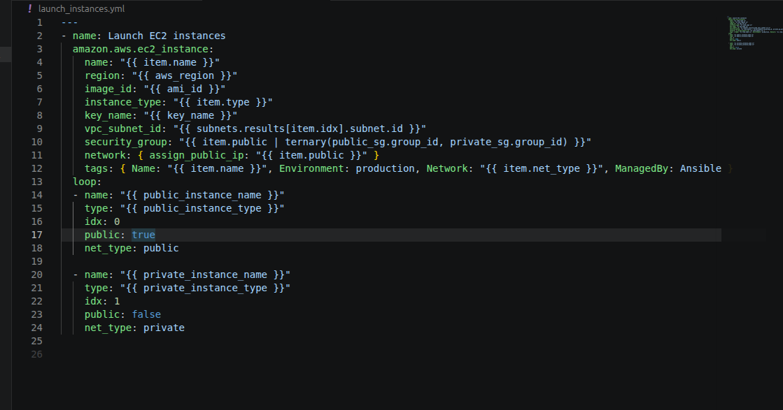

Execution -

- sudo apt update
- sudo apt install python3 python3-pip
- sudo apt install -y python3-boto3 python3-botocore
- ansible-galaxy collection install amazon.aws community.aws

- Aws configure
- AWS Access Key ID: <paste access key ID>
- AWS Secret Access Key : <paste secret access key>
- Default region name : eu-west-2
- Default output format : json

- ansible-playbook playbook.yml --syntax-check
- ansible-playbook playbook.yml

Output -
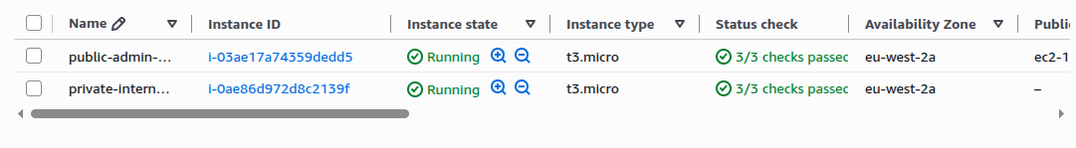

- chmod 400 /path/to/ssh key.pem
- ssh -i /path/to/key.pem -A ec2-user@<public_ip>
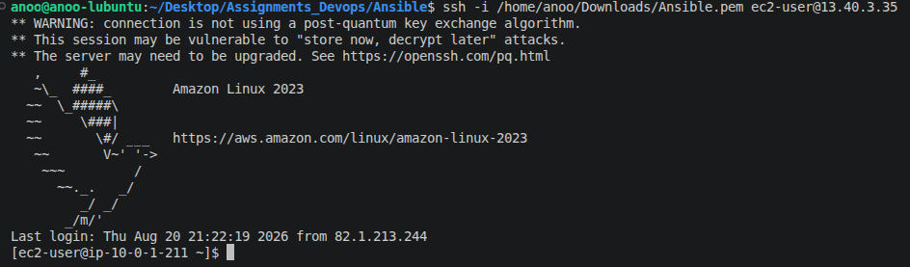
- scp -i Ansible.pem Ansible.pem ec2-user@your-ec2-ip:/home/username/
- Chmod 400 Ansible.pem
- ssh ec2-user@<private_ip>

